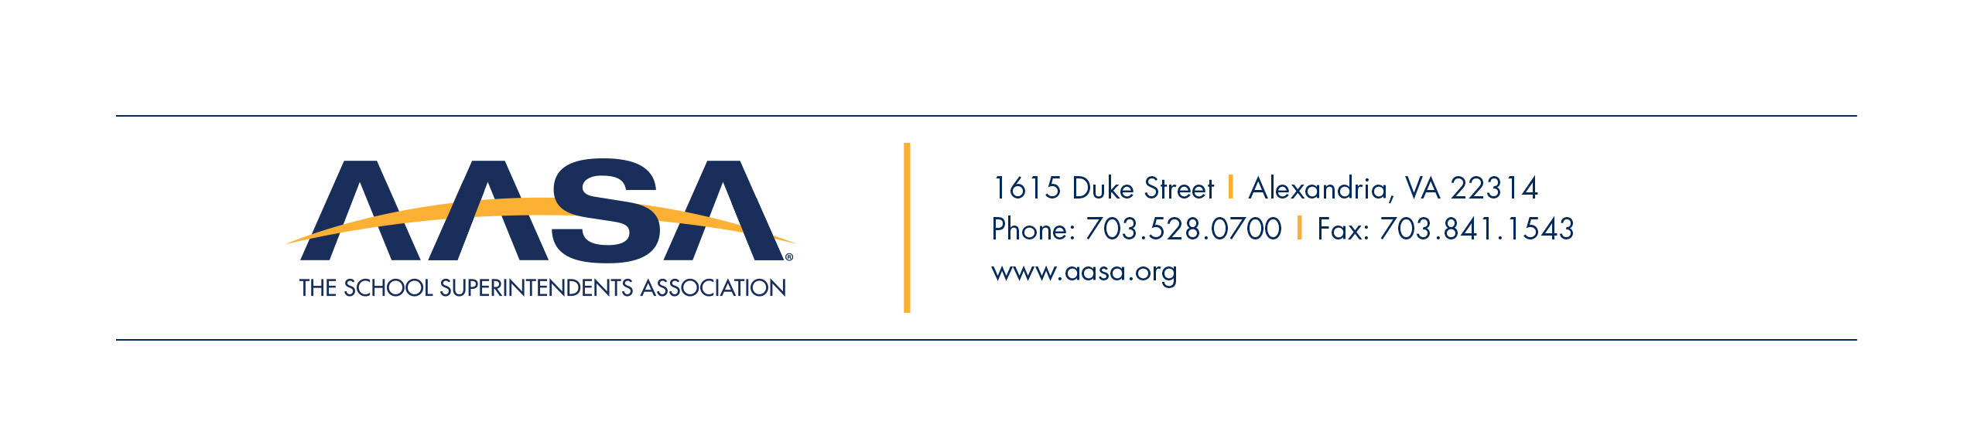

FOR IMMEDIATE RELEASE
Contact:
James Minichello
703-875-0723
703-774-6953 (cell)
jminichello@aasa.org

(Feel free to change the contact information)

(Your School District) Launches Campaign to Support Public Schools

(Your City/Town, State Abb.) – (Date) – The (Name of School District) is affirming its full support behind a national effort to highlight the success of public education and demonstrate why public schools are essential to develop future generations of successful students.

“I am excited that our Board of Education adopted an official resolution in support of the I Love Public Education campaign as a way to maintain this country’s status as a world leader,” said (First, Last Name of Superintendent), superintendent, (Name of School District). “It is time to change the national dialogue around public education. This campaign creates a platform for the members of our community to join together and express why they love public education and why it’s so critical in our global economy.”

(Feel free to edit/modify suggested quote.)

In July 2017, AASA, The School Superintendents Association, launched the I Love Public Education campaign, which highlights the critical roles public schools play as the bedrock of our civic society. “We stand firmly behind the importance of equity, which is at the center of this campaign, with the long-term goal of ensuring the (number of students) students attending our schools lead successful lives,” added (Last Name of Superintendent).

“The I Love Public Education campaign is a direct extension of our commitment to ensure all students have access to a high quality public education,” said Daniel A. Domenech, executive director, AASA. “At a time when education policy may be momentarily distracted from the rich history of our public schools and the roles they play in preparing students to be productive adults, who better than school system leaders to lead, shape and grow a broad dialogue and support for loving public education?”

A key component of the campaign includes fostering conversations and strong actions to allow schools to provide the best support to students. Educators are encouraged to join the conversation via Twitter at #LovePublicEducation.

The campaign website, www.lovepubliceducation.org, includes details on how anyone associated with advocating for the strength of public education can get involved.

###

About AASA
AASA, The School Superintendents Association, founded in 1865, is the professional organization for more than 13,000 educational leaders in the United States and throughout the world. AASA’s mission is to support and develop effective school system leaders who are dedicated to the highest quality public education for all children. For more information, visit www.aasa.org.

(Feel free to strike AASA’s “blurb” and use your own district’s “blurb” in its place.)

